SPRING BOOT CRUD RESTFUL WEB SERVICES API

Resources:

GET – <http://localhost:9001/friends>

GET BY ID – <http://localhost:9001/friends/view/:id>

POST – <http://localhost:9001/friends/add>

PUT – <http://localhost:9001/friends/update/:id>

DELETE – <http://localhost:9001/friends/delete/:id>

**CONTROLLERS**

Controllers are the one who holds the requests and responses in HTTP.

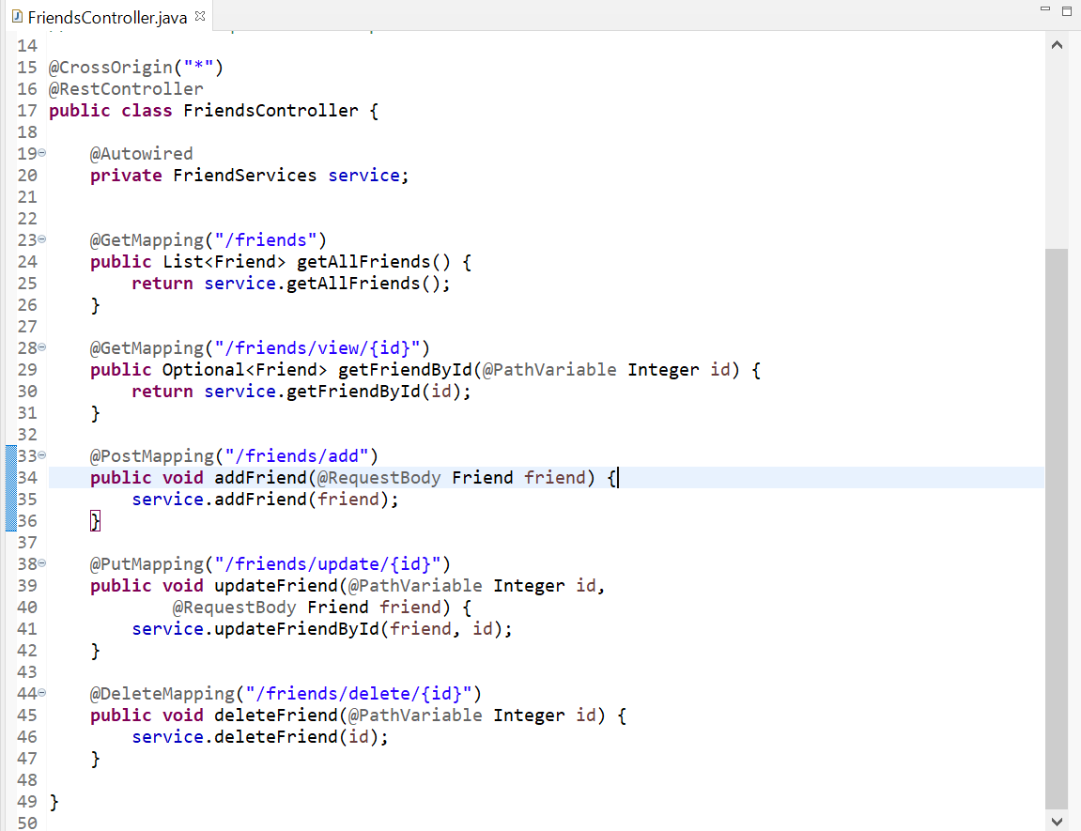

**ENTITY**

Entities from Database

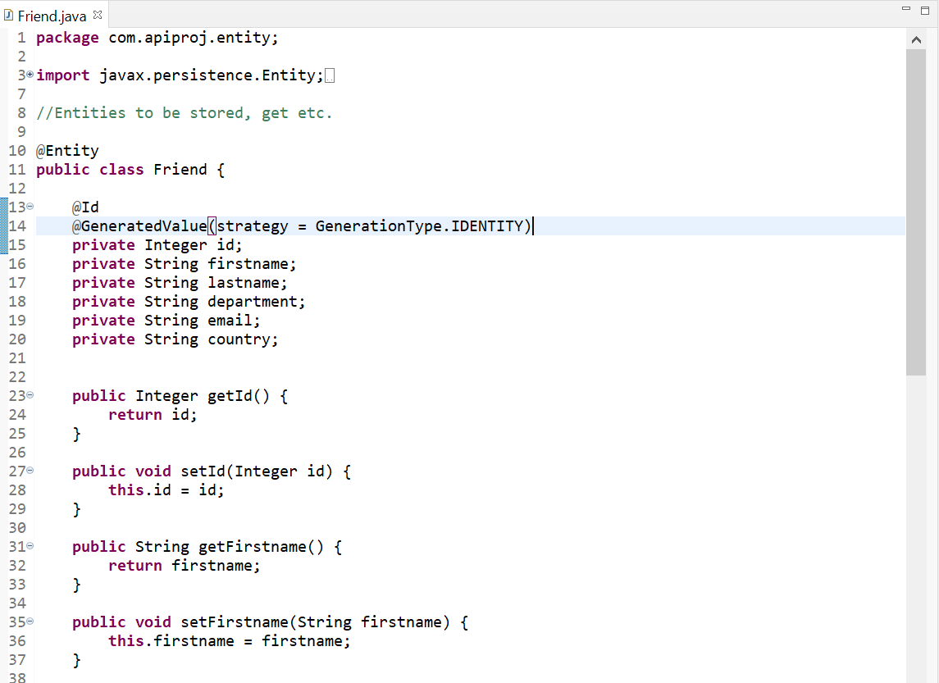

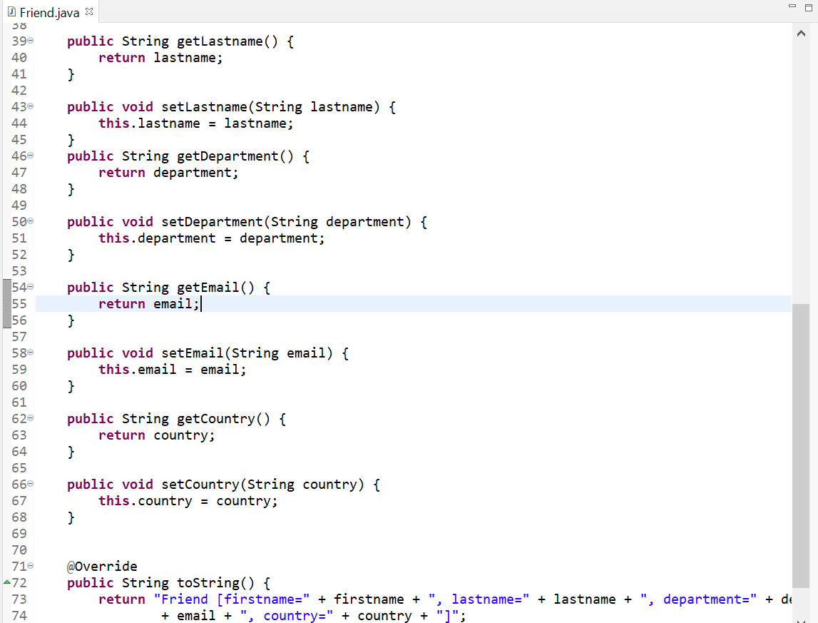

**JPA REPOSITORY**

JPA is the one communicates with the database

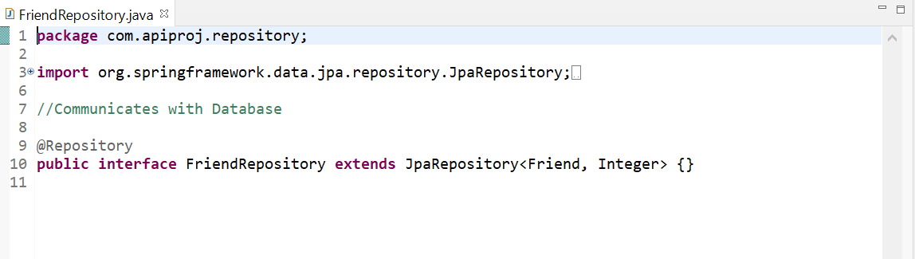

**SERVICES**

Services holds the business logic

